Standard Operating Procedures Central Massachusetts Regional Stormwater Coalition SOP 20: Operations and Maintenance of Municipal Buildings and Facilities

Inventory of Municipal Buildings and Facilities
##MUNICIPALITY, Massachusetts

Name of Building/Facility | Location | Manager/Contact – Name, Position, Department, Phone Number | Potential Stormwater Pollutant Sources (e.g., trash containers, fertilizers, fuel)

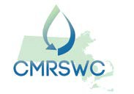
June 2019

