Standard Operating Procedures Central Massachusetts Regional Stormwater Coalition SOP 21: Operations and Maintenance of Municipal Vehicles and Equipment

Inventory of Municipal Vehicles and Equipment
##MUNICIPALITY, Massachusetts

Vehicle/Equipment | Department/Location | Contact – Name, Position, Department, Phone Number | Date of Last Inspection/Calibration

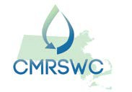
June 2019

